1. Home page
2. All about me
   1. A brief about my life
      1. Here is just a little bit about me, I am a full-time student at John wood community college. I am majoring in the field of Graphic design; I have always had a very strong and high passion for art. All through high school I took every art class that I could get my hands on and I got to take a Graphic design class and Graphic communications class, this is really where I found what career I wanted to do. As of now I am a part time worker at The Home Depot, but one day I hope to be creating and designing things for people weather that be personal items or things for the business. 
   2. Hobbies I enjoy
      1. I enjoy anything that involves me being creative or thinking outside the box, I really enjoy being able to put my mind to it and see what I can make out of it. I have recently made hangers for a bridal party by using my circuit, but there needed to be more than just lettering on the hangers so I thought what way could I make these hangers their own and like ones I have never seen before. I added flowers to help add in the colors of the wedding but to also add a three-D design to them. I really thought about how these would look in pictures from a distance with the dresses hanging on them. So out of every hobby I can think of would be designing something and being artsy and creative. I love to make art and push myself even if the projects end in a complete flop. 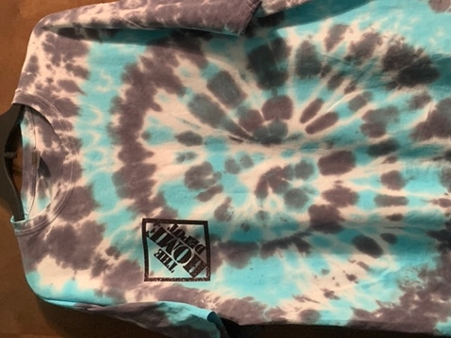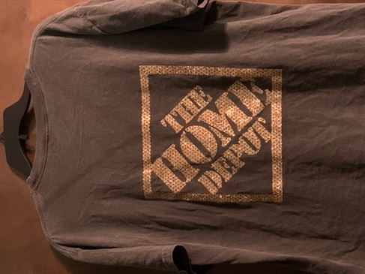
   3. Family
      1. I come from a family of six, I am one out of four children. With two older sisters and one little brother. Making our poor little brother the only boy. My two older sisters are my Half siblings even though I don’t think of them that way. I am a big family person and I say this because I couldn’t be doing what I love to day by getting my education for a field that I love and strive to be apart of. My family has pushed me to be the best I can be in school and to do the things that I love and that will benefit me in the long run.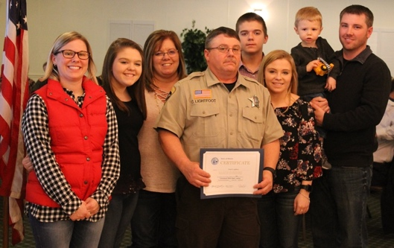
3. Contact us
   1. Who your contacting
      1. Raelyn Lightfoot
   2. Phone number
      1. 217-440-0716
   3. Email
      1. [Raeraelightfoot@gmail.com](mailto:Raeraelightfoot@gmail.com)